Consensus Electoral Map August 2, 2020
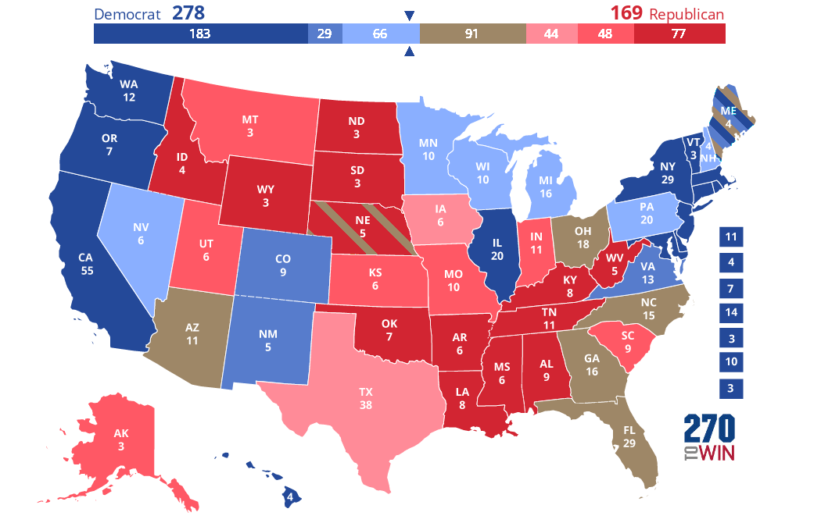

In the 2020 projected map above, add the brown to the red/pink and there are 278 votes for the Democrat and 260 for the Republican. In the 2016 election, the Republican won Pennsylvania, Michigan and Wisconsin. In the 2012 election, the Democrat won Ohio, Florida, and Iowa.
===========================================

Today, August 2, 2020, I heard on the news the term: SPLASHDOWN
It seems like every American space exploration ended with that term when I was younger, but actually: there has not been a water landing of a spacecraft in 45 years, when in 1975 the Apollo-Soyuz joint mission took place. This was the first water landing in the Gulf of Mexico and closest landing to the main United States landmass. I am wondering if a future landing will be near Houston. That would be appropriate. Nowadays, the term, Splashdown, is most commonly used in recreational waterparks.

