Global Weather Changes

Above-average February temperatures set over 1,000 new records in US alone
By Adriana Navarro, AccuWeather staff writer
Updated Mar. 15, 2020 9:33 AM
After delivering waves of spring-like temperatures across the globe and even toppling a few daily highs, February 2020 ranked globally as the second warmest on record, which date back to 1880.
The month's global land and ocean surface temperature departure from average measured 1.17 degrees Celsius (2.11 F) above the 20th century average, according to the National Oceanic and Atmospheric Administration's National Climate Report. This falls less than a tenth of a degree from February 2016's departure of 1.26 degrees Celsius (2.27 F), which was the warmest recorded February on record.
In Fahrenheit, the difference falls at 0.16 of a degree. In 2019, the average fell at 0.86 degrees Celsius above average (1.55 F).
This was the 44th consecutive February and 422nd consecutive month with temperatures nominally above the 20th century average, according to NOAA.
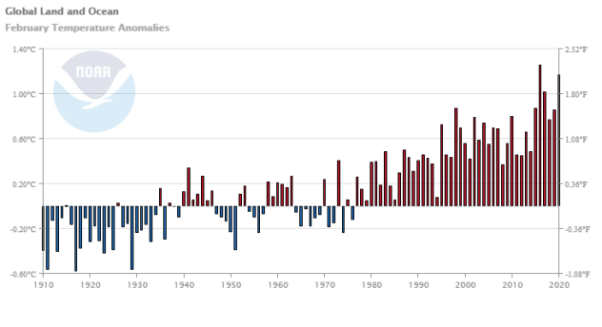

Related:
Ghost ship lands in ‘one in a million’ place during Storm Dennis
Storm Ciara cuts power to more than 500,000 in UK, brings travel to a standstill in northern Europe
Weather station in Antarctica records high of 65, the continent’s hottest temperature ever

Floods in Cairo! Heavy rain brings flash floods in Egypt!
73,704 views
•Mar 12, 2020
795 46 Share
Save
chave weather - daily videos
14.6K subscribers
Heavy rains bring flash flooding to Cairo, Egypt! 12th March 2020. القاهرة. Dragon Storm.

Global warming influence on extreme weather events has been frequently underestimated
Date:
March 18, 2020
Source:
Stanford University
Summary:
Analysis shows global warming is intensifying the occurrence of unprecedented hot spells and downpours faster than predicted by historical trends.
Share:
FULL STORY

A new Stanford study reveals that a common scientific approach of predicting the likelihood of future extreme weather events by analyzing how frequently they occurred in the past can lead to significant underestimates -- with potentially significant consequences for people's lives.
Stanford climate scientist Noah Diffenbaugh found that predictions that relied only on historical observations underestimated by about half the actual number of extremely hot days in Europe and East Asia, and the number of extremely wet days in the U.S., Europe and East Asia.
The paper, published March 18 in Science Advances, illustrates how even small increases in global warming can cause large upticks in the probability of extreme weather events, particularly heat waves and heavy rainfall. The new results analyzing climate change connections to unprecedented weather events could help to make global risk management more effective.
"We are seeing year after year how the rising incidence of extreme events is causing significant impacts on people and ecosystems," Diffenbaugh said. "One of the main challenges in becoming more resilient to these extremes is accurately predicting how the global warming that's already happened has changed the odds of events that fall outside of our historical experience."
A changing world
For decades, engineers, land-use planners and risk managers have used historical weather observations from thermometers, rain gauges and satellites to calculate the probability of extreme events. Those calculations -- meant to inform projects ranging from housing developments to highways -- have traditionally relied on the assumption that the risk of extremes could be assessed using only historical observations. However, a warming world has made many extreme weather events more frequent, intense and widespread, a trend that is likely to intensify, according to the U.S. government.
Scientists trying to isolate the influence of human-caused climate change on the probability and/or severity of individual weather events have faced two major obstacles. There are relatively few such events in the historical record, making verification difficult, and global warming is changing the atmosphere and ocean in ways that may have already affected the odds of extreme weather conditions.
Predicted versus observed extreme weather
In the new study, Diffenbaugh, the Kara J. Foundation professor at Stanford's School of Earth, Energy & Environmental Sciences, revisited previous extreme event papers he and his colleagues had published in recent years. Diffenbaugh wondered if he could use the frequency of record-setting weather events from 2006 to 2017 to evaluate the predictions his group had made using data from 1961 to 2005. He found in some cases the actual increase in extreme events was much larger than what had been predicted.
"When I first looked at the results, I had this sinking feeling that our method for analyzing these extreme events could be all wrong," said Diffenbaugh, who is also the Kimmelman Family senior fellow in the Stanford Woods Institute for the Environment. "As it turned out, the method actually worked very well for the period that we had originally analyzed -- it's just that global warming has had a really strong effect over the last decade."
Interestingly, Diffenbaugh also found that climate models were able to more accurately predict the future occurrence of record-setting events. While acknowledging that climate models still contain important uncertainties, Diffenbaugh says the study identifies the potential for new techniques that incorporate both historical observations and climate models to create more accurate, robust risk management tools.
"The good news," Diffenbaugh said, "is that these new results identify some real potential to help policymakers, engineers and others who manage risk to integrate the effects of global warming into their decisions."

