Jennie Geosling (1922-2018)

Born: Poznan, Poland - June 25, 1922

Passed: West Allis, Wisconsin - September 29, 2018

There are several pictures in this file.

I have documented pictures from our visits to the family.

There are many more pictures that were taken.

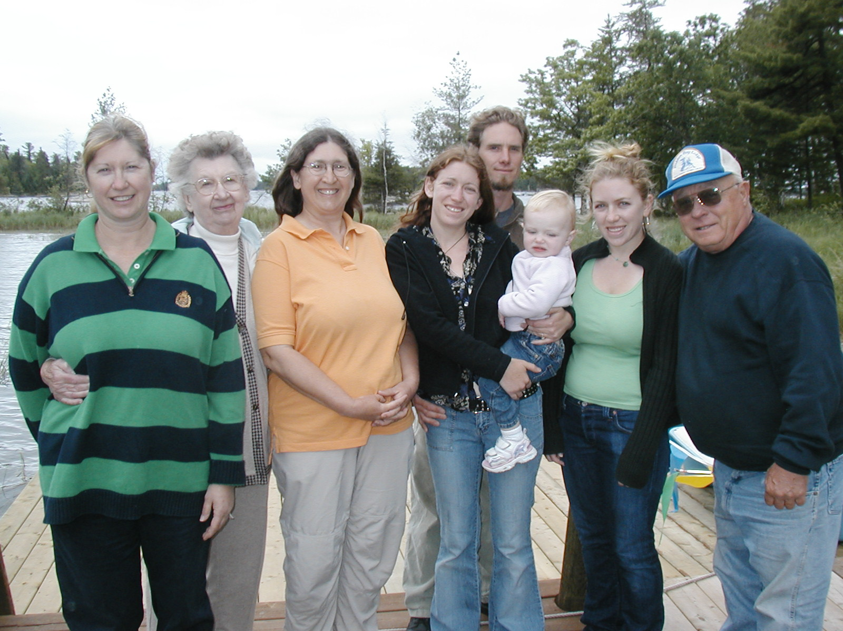

At Loon-and-tick Island in July 2004. Katy is holding Seanna who is 21 months old.

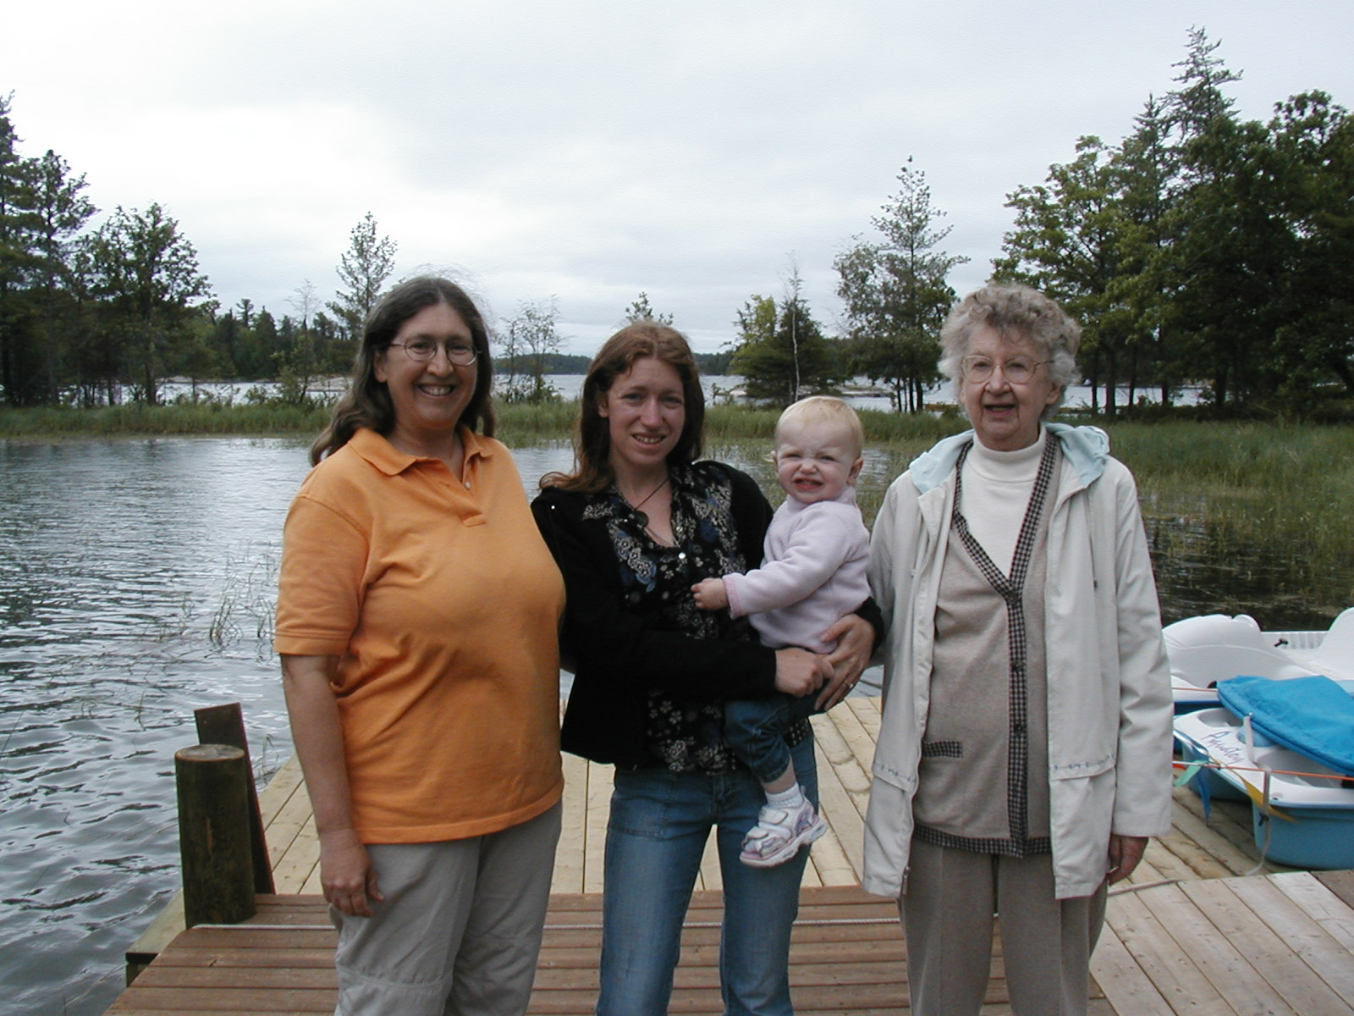

Chris, Katy, Seanna, and Jennie at Loon-and-tick Island in July 2004.

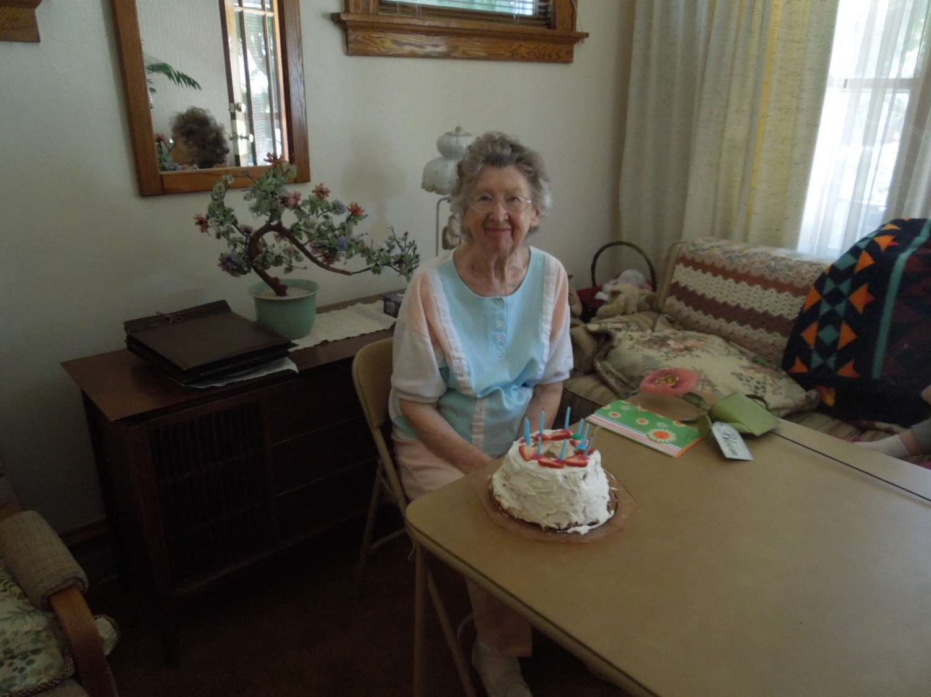
At Jennie’s 90th Birthday party in June 2012 in her living room.

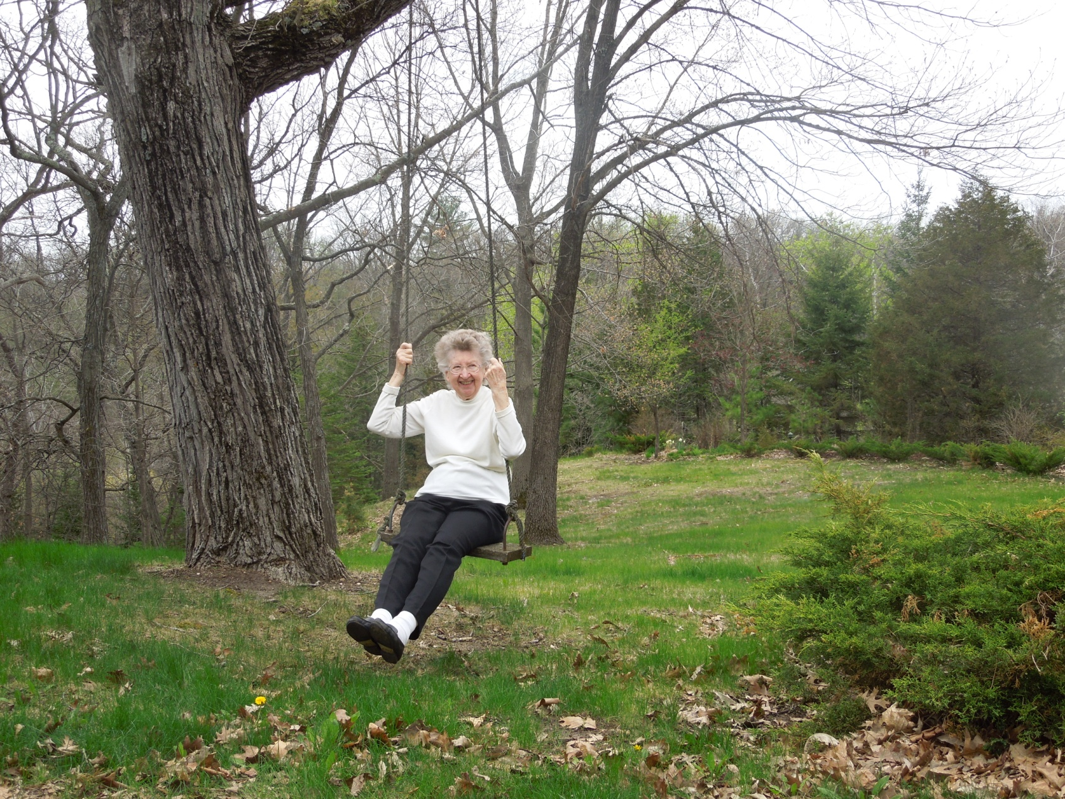
Mother’s Day at Ron and Marilyn’s yard in Mukwonago in May 2014

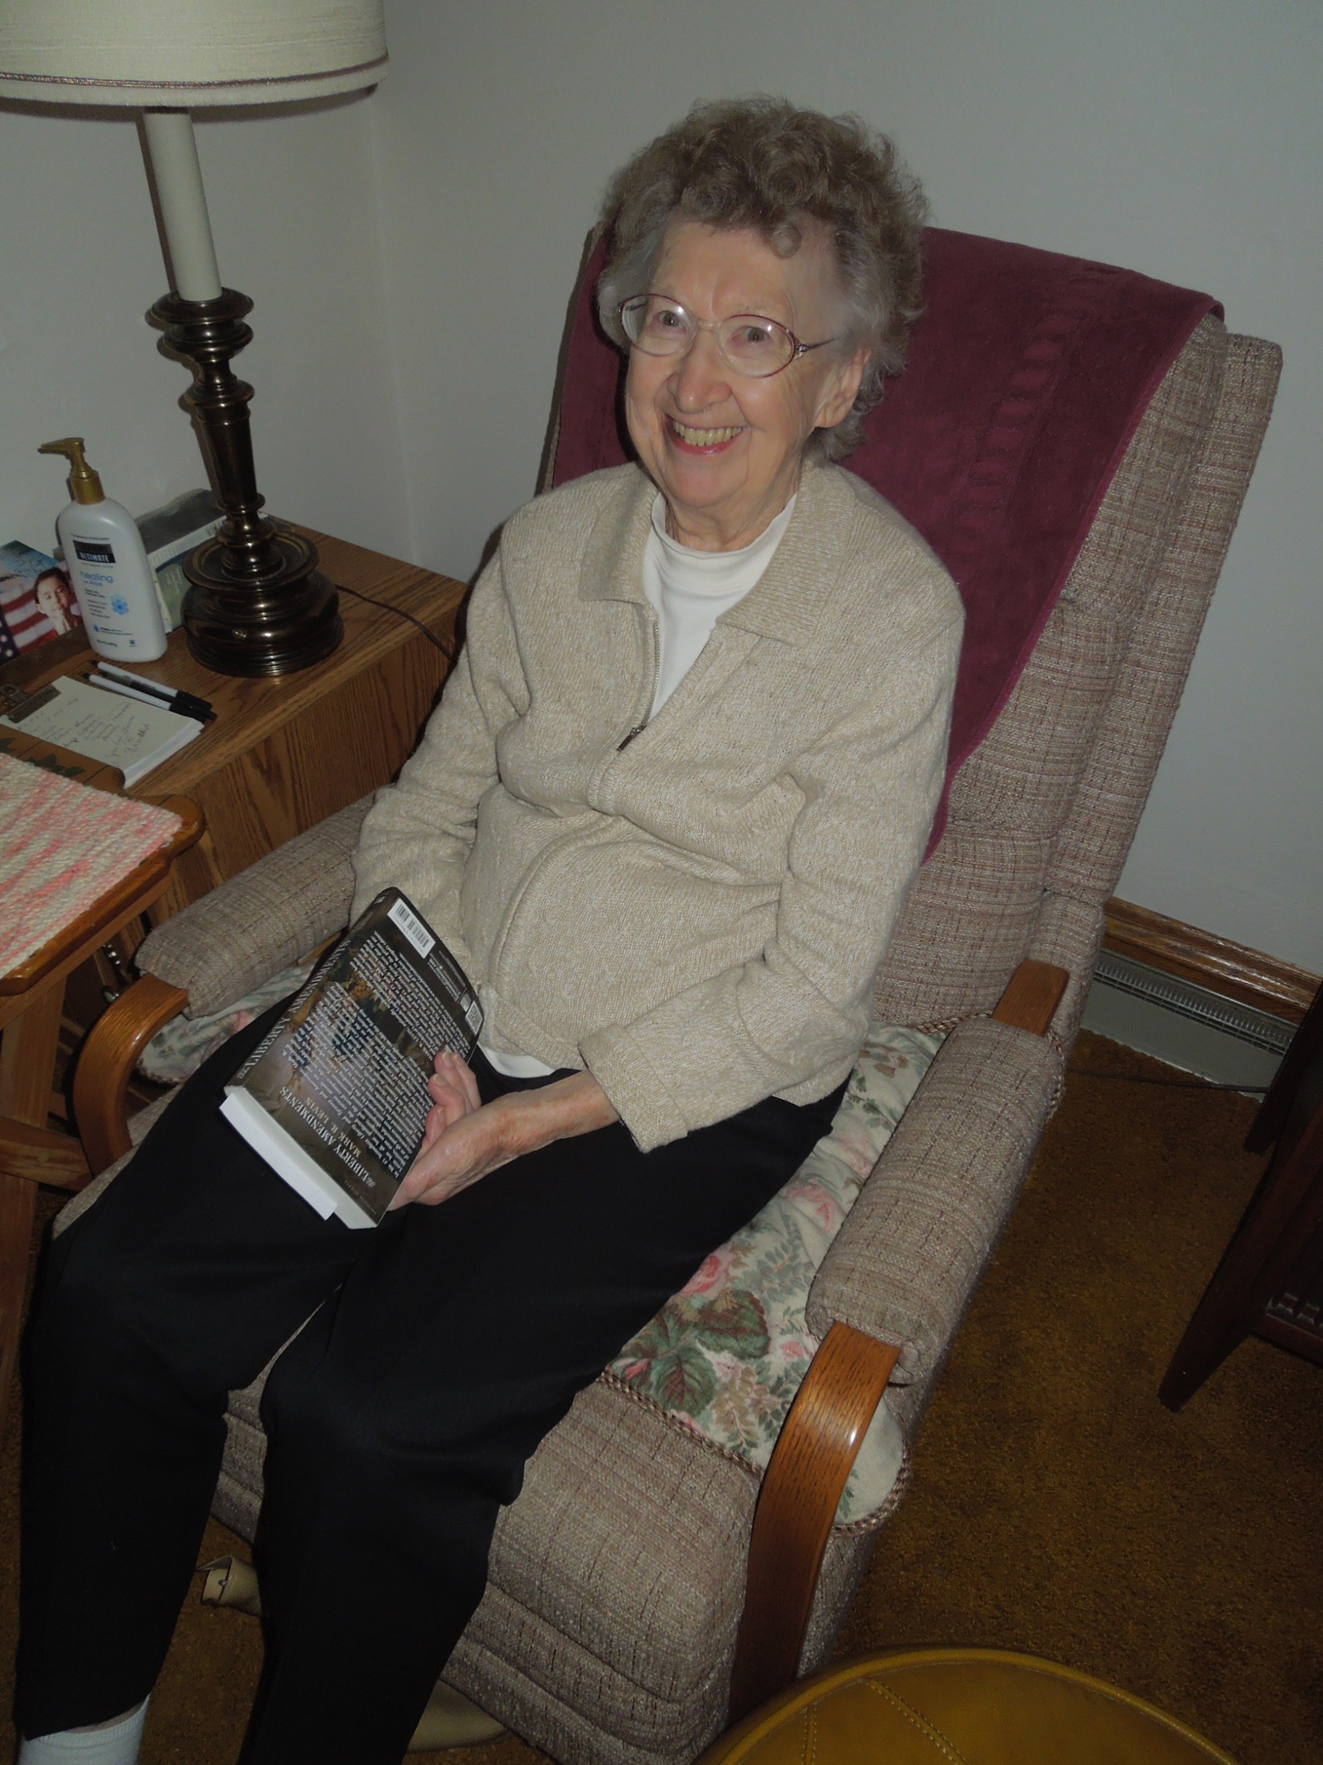

Jennie reading at home in West Allis in October 2014

