Statue in the Park
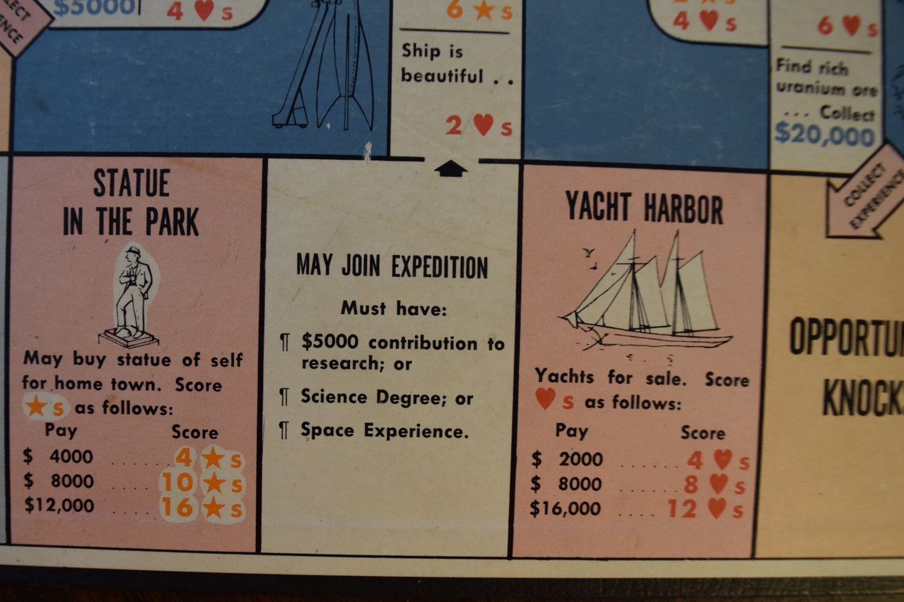
The title is named after a space in the 1957 version of the board game “Careers”. In that game, the players try to achieve their goals of fame, happiness, and money by landing on various spaces. The Statue in the Park space allows the person who lands there to exchange money for fame by contributing to a statue. The original version has become dated but the revised modern game is not as interesting.
In 2001, the Taliban controlled an area of Afghanistan and decided to destroy the monuments to Buddha. Many groups protested that destruction of historical monuments. Computer projections are now used to bring back the images of these monuments. My friend Dave made the following comment: Most commentators in the West were appalled when Islamic State blew up the huge Buddhas. When you start to destroy the history you find offensive, where does it stop?
It is now 2020, and in the United States, there is controversy about statues that represent historical figures that have become unpopular for various reasons. Throughout the United States, at the end of the reconstruction period after the Civil War (Confederate version: War between the States). Somehow, the war which was fought over furthering the practice of slavery (which Lincoln opposed), was recast as a war defending states’ rights.
Many of these statues are in the former Confederate States, date from the period 1900-1920, honor the end of reconstruction, and show that white people were firmly back in control of the political process. I have found that reading the dedication speeches, looking at the organizations that paid for the statues, and the Ku Klux Klan participation is informative as to the real purpose of these statues.
In California, the founder of a series of Spanish Missions, Father Junipero Serra has gone from a historical settler to an abuser of native Americans. In the process of coercing the natives to adopt Spanish culture and religion, natives were gathered at the Missions and provided needed labor. This process allowed the European diseases to greatly reduce the number of native Americans who lived in California. In June 2020, in both Los Angeles and San Francisco , statues of Serra were toppled by hostile groups of activists, or are they anarchists? This procedure left an unsafe pedestal (or plinth) in the park and dumped the statue on a nearby street for the city to clean up the mess (and pay for the process). In some cases, different groups have had clashes that required police action to mediate disagreements whether statues should be removed. As an American, I would think that such issues should be solved in the political process not by gangs of people in the street. Maybe this is an idea for a new board game called “Statue Wars”. In any case, do all public monuments need protection against groups that want to destroy them? Although the mission system did not work out well for many native Americans, perhaps the control of California and the West by a repressive Mexican Government from 1815 to 1848 was even worse.
Each state is allowed two statues that reside at the Capitol in Washington, DC. The two from California are currently Father Junipero Serra and Ronald Reagan. Neither person was born in California. I would think that the Father Serra statue will be removed sometime in the future by the State of California, since his cultural contribution to the state has come under question. • California: A resolution to replace California's statue of Serra with one of astronaut Sally Ride [My comment: who was born in California] passed the state senate in April 2015, but the vote in the state assembly was placed on hold as the date for Serra's canonization as a saint approached. Governor Jerry Brown declared in July 2015 that the Serra statue would stay in the Capitol “until the end of time." Many other states have contributed statues of former slave owners or Confederate leaders.
=========================================================
Now for the topic of eugenics: (google states…) the study of how to arrange reproduction within a human population to increase the occurrence of heritable characteristics regarded as desirable. Developed largely by Francis Galton as a method of improving the human race, it fell into disfavor only after the perversion of its doctrines by the Nazis. (my comments) Even after World War II, the movement influenced actions. The question here is whether support of eugenics (like slavery) should disqualify an individual from receiving honors from society, a university, or history. The referenced article summarizes the eugenics activities in the United States. Involuntary sterilization of women was performed in California as recently as 2010.
Even though the movement was more commonly espoused in the early part of the 20th Century, I am quite surprised at the list of eugenics supporters, who otherwise contributed to scientific and cultural accomplishments. Names of buildings at USC and Caltech have honored eugenics supporters. USC recently decided to remove the Von Kleinsmid name from the tall international center building.
Back in the 1920's and 1930's there was a lot of eugenics going on that had to do with Hitler vs. Jews, involuntary sterilization of people in asylums, etc. Whether or not such people who supported the eugenics movement (or old confederate soldiers) should have an honored place (a building or a statue) in history is a political question. Many people in the past have supported or engaged in activities (like slave holding) that are no longer acceptable. Does great political or scientific progress erase the actions of the people that were against humanity. Earl Warren as Attorney General and Governor or California supported the imprisonment of Japanese Americans; the Governor of Hawaii did not allow it. Earl Warren then became the Supreme Court Chief Justice and later regretted his prior actions. Does he deserve a "Statue in the Park"?
I am the product of two deaf parents. Some deaf people in the United States were routinely in the 1920s and 1930s sent to mental asylums, and subjected to involuntary sterilization. The country was therefore deprived of the potential children of deaf parents. See the movie Children of a Lesser God. Fortunately, Milliken's experiments in Physics were accepted; his eugenics views were not. Should he and others who supported eugenics be honored at Caltech with their names on buildings?
=========================================================
In the news recently: remove Washington, Jefferson, and Teddy Roosevelt from Mount Rushmore!
Remove the confederates on Stone Mountain in Georgia. Question1: Could the expense of removal be better used to provide housing and food for people. Question2: Will tourism reduction adversely affect the local economy? Question3: Is this historically significant art?
Rename the town of Fort Bragg in California. Question4: Is it fair to make the people of the town pay for the expenses of renaming? Question5: Will travelers be able to find the new town by name?
Question6: What about all those military bases (mostly in the South) named after Confederate soldiers?
Question7: How about all the professional sports team and high school sports mascots that could be construed as racist, denigrating, or supportive of outdated causes?

